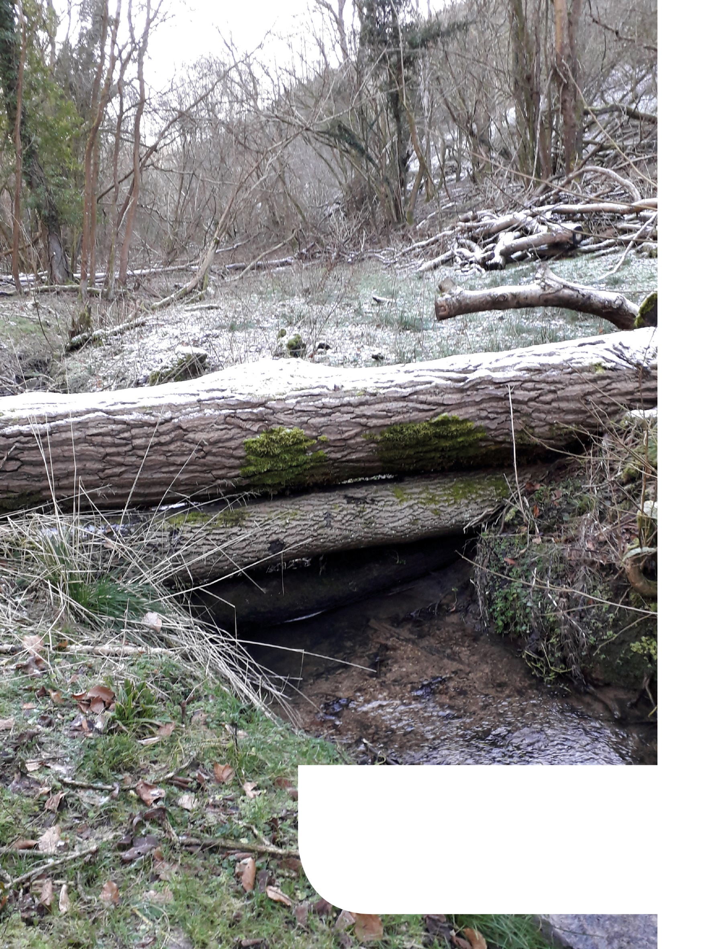



Calderdale Council   
Natural Flood Management   
Grant Scheme

**Application Form**

**Section 1. About the Applicant**

|  |  |
| --- | --- |
| **1.1 Applicant Name** | Click here to enter text. |
|  |  |
| **1.2 Landowner name (if different)** | Click here to enter text. |
| **1.3 Contact details** |  |
| Address | Click here to enter text. |
|  |  |
| Telephone Number | Click here to enter text. |
|  |  |
| Email | Click here to enter text. |
|  |  |
| **1.4 Status of Applicant – Landowner/Tenant/Agent/Employee. (If you are a tenant, please include written landlord’s consent for the work identified in this application.)** | |
| Click here to enter text. | |
|  | |
| **1.5 Do any other parties have a legal interest over the land included in this application? If yes please list them below and give details about the nature of their involvement. All parties with a legal interest over the land must be informed of the works in writing.** | |
| Click here to enter text. | |
|  | |
| **1.6 Will you have control of the land included for the full period of time covered by the works identified in this application including the maintenance period?** | |
| Click here to enter text. | |
|  | |
| **1.7 Have you applied previously to the Calderdale NFM fund for works on this land? If yes, please give details of previous applications, successful or unsuccessful.** | |
| Click here to enter text. | |

|  |
| --- |
| **1.8 Have you received any general or agricultural de minimis state aid payments in the 3 years prior to the date of this claim?** |
| Amount:Click here to enter text.  Details:Click here to enter text. |
| **1.9 Are you Value Added Tax (VAT) registered?** |
| Yes/No |
| **Please provide your VAT Registration Number:** |
| Click here to enter text. |
|  |
| **Are you able to recover VAT on the costs associated with your application?**  Yes/No |
|  |
| N.B. VAT should only be included as a cost in your application if you cannot recover it from HM Revenue and Customs.  If we have agreed to fund any or all of the VAT costs associated with your Project and you subsequently recover any VAT, you must pay us back immediately any of the VAT that has been paid for with the grant. |

|  |  |  |  |  |  |  |  |  |  |  |  |  |
| --- | --- | --- | --- | --- | --- | --- | --- | --- | --- | --- | --- | --- |
| **2.1 Site name** | | | Click here to enter text. | | | | | | | | | |
|  | | | | | | | | | | | | |
| **2.2 Rural Payments Agency (RPA) Single Business Identifier number or County Parish Holding number (if you have one)** | | | | | | | | | | | | |
| Click here to enter text. | | | | | | | | | | | | |
|  | | | | | | | | | | | | |
| **2.3 Site Details** | | | | | | | | | | | | |
| **(A) Land parcel reference number  (on your map)** | **(B) Grid Reference** | **(C) Area (ha)** | | **(D) Land Type** | **(E) Designations YES -Y or NO -N** | | | | | | | |
| **Site of Special Scientific Interest** | **Special Protection Area** | **Common Land** | **Tree Preservation Order** | **Scheduled Monument** | **Registered Park and Garden** | **Local wildlife site** | **Other (please give details)** |
| Nr | Nr | Nr | | Enter text. |  |  |  |  |  |  |  |  |
| Nr | Nr | Nr | | Enter text. |  |  |  |  |  |  |  |  |
| Nr | Nr | Nr | | Enter text. |  |  |  |  |  |  |  |  |
| Nr | Nr | Nr | | Enter text. |  |  |  |  |  |  |  |  |
| Nr | Nr | Nr | | Enter text. |  |  |  |  |  |  |  |  |
| Nr | Nr | Nr | | Enter text. |  |  |  |  |  |  |  |  |
| Nr | Nr | Nr | | Enter text. |  |  |  |  |  |  |  |  |
| Nr | Nr | Nr | | Enter text. |  |  |  |  |  |  |  |  |
| Nr | Nr | Nr | | Enter text. |  |  |  |  |  |  |  |  |
| Nr | Nr | Nr | | Enter text. |  |  |  |  |  |  |  |  |
| Nr | Nr | Nr | | Enter text. |  |  |  |  |  |  |  |  |
| Nr | Nr | Nr | | Enter text. |  |  |  |  |  |  |  |  |
| Nr | Nr | Nr | | Enter text. |  |  |  |  |  |  |  |  |
| Nr | Nr | Nr | | Enter text. |  |  |  |  |  |  |  |  |
| Nr | Nr | Nr | | Enter text. |  |  |  |  |  |  |  |  |
| Nr | Nr | Nr | | Enter text. |  |  |  |  |  |  |  |  |
| Nr | Nr | Nr | | Enter text. |  |  |  |  |  |  |  |  |
| Nr | Nr | Nr | | Enter text. |  |  |  |  |  |  |  |  |
| Nr | Nr | Nr | | Enter text. |  |  |  |  |  |  |  |  |
| Nr | Nr | Nr | | Enter text. |  |  |  |  |  |  |  |  |
| Nr | Nr | Nr | | Enter text. |  |  |  |  |  |  |  |  |
| Nr | Nr | Nr | | Enter text. |  |  |  |  |  |  |  |  |
| Nr | Nr | Nr | | Enter text. |  |  |  |  |  |  |  |  |
| Nr | Nr | Nr | | Enter text. |  |  |  |  |  |  |  |  |
| Nr | Nr | Nr | | Enter text. |  |  |  |  |  |  |  |  |

**Section 2. About the land**

|  |
| --- |
|  |
| **2.4 Are you aware of any agreements or contractual restrictions upon the land use during the period covered by the activities included in this application? If Yes, Please give details.** |
| Click here to enter text. |
|  |
| **2.5 Does the work included in this application require any consents, for example, Felling Licences or Planning Permission?**  **-If yes:**  **a) Has permission been granted?** |
| Click here to enter text. |
| **b) Please give details below.** |
| Click here to enter text. |
|  |
| **2.6 Are you aware of any rare, threatened or endangered species or habitats within the land included in this application?** **If Yes, please give details below.** |
| Click here to enter text. |
|  |
| **2.7 Are you aware of any pre-existing hazards or issues relating this land? If Yes, Please give details below.** |
| Click here to enter text. |
|  |
| **2.8 If you have answered ‘Yes’ to any of the questions from in Section 2 above please provide any additional details here and include information relating to their location on your application map.** |
| Click here to enter text. |

**Section 3. About the works**

|  |  |
| --- | --- |
| **3.1 What is the value of the works based on the output of your Grant calculator?** | |
| **Capital- £** | Click here to enter text. |
| **Maintenance- £** | Click here to enter text. |
| **Project total- £** | Click here to enter text. |

**3.2 When would you like to start the works?**

|  |  |  |
| --- | --- | --- |
| Day | Month | Year |
| DD | MM. | YYYY. |

**3.3 By which date would all your capital items have been installed?**

|  |  |  |
| --- | --- | --- |
| Day | Month | Year |
| DD | MM. | YYYY. |

|  |
| --- |
| **3.4 Does this application form part of a collaboration with any other applications to this scheme?** |
| Click here to enter text. |
|  |
| **3.5 Please describe the works below, include photographs where possible (no more than 300 words)** |
| Click here to enter text. |

**Section 4. Declaration**

|  |  |  |  |  |
| --- | --- | --- | --- | --- |
| **4.1 I certify that the information provided is correct, and any changes in circumstance will be notified to Calderdale Council at the earliest opportunity.** | | | | |
| **Signed:** | Click here to enter text. | | | |
|  |  | | | |
| **Date:** | Day | Month | Year |  |
|  | DD | MM. | YYYY. |  |

**Privacy Notice:**

Calderdale Council is registered with the information Commissioners Office (ICO) under the provisions of the Data Protection Act 2018. The Council takes its responsibilities under the Act very seriously.

The information provided by you is collected purely for the purposes of responding to your request for service in relation to Flood Strategy and Planning. We need to collect this information in order to contact you, if required, to request further information or provide you with the outcome of your request. To handle your request we share data with all funders of the Calderdale Natural Flood Management grant scheme and members of the Natural Flood Management funding sub-group.

Completion of this form/sharing of your information constitutes explicit consent from you to us to process your data for this purpose. You may withdraw your consent at any time by writing to: Helen Martin, Performance Manager, Strategic Infrastructure, Ainley Depot, Huddersfield Road, Elland HX5 9JR. In addition you have the right to see what information is held about you, to have inaccurate information removed from our system unless we are required by law or statutory purpose to keep it and the right to complain to the Data Protection Officer if you feel that your data has not been handled in accordance with the law.

The Councils Data Protection Officer is Tracie Robinson and can be contacted at information_management@calderdale.gov.uk

Your name and contact details are recorded electronically on our system to maintain up to date records. This information will be kept for a maximum of seven years after the year the record was created or until such time as the data is reviewed by us or removed at your request.

**Section 5. Checklist**

**Have you:-**

**Filled in all the questions in the Application Form?**

**Filled in the Grant Calculator?**

**Attached a Map?**

**Attached all the necessary permissions?**

* **Landowner's consent if you are not the owner**
* **Felling Licences (if required)**
* **Planning Permission (if required)**
* **Consent from Natural England (if required)**